Experiment 4.4
Analysis of Continuous-Time System
Aim:
To analyze a continuous-time system by applying a continuous-time input signal and
examining the system's output. The Aim is to understand the system's behavior and verify its properties such as linearity, time-invariance, causality, and stability.
Program:
% Analysis of Continuous-Time System
clc;
clear;
close all;
% Time axis
t = 0:0.01:10;
% Input signal
x = sin(2*pi*t);
% Delayed signal x(t-1)
x_delay = sin(2*pi*(t-1));
% System output
y = x + 0.5*x_delay;
% Plotting
figure;
subplot(2,1,1);
plot(t,x,'LineWidth',2);
grid on;
title('Input Signal x(t)');
xlabel('Time (s)');
ylabel('Amplitude');
subplot(2,1,2);
plot(t,y,'LineWidth',2);
grid on;
title('Output Signal y(t)=x(t)+0.5x(t-1)');
xlabel('Time (s)');
ylabel('Amplitude');
Output Waveform:
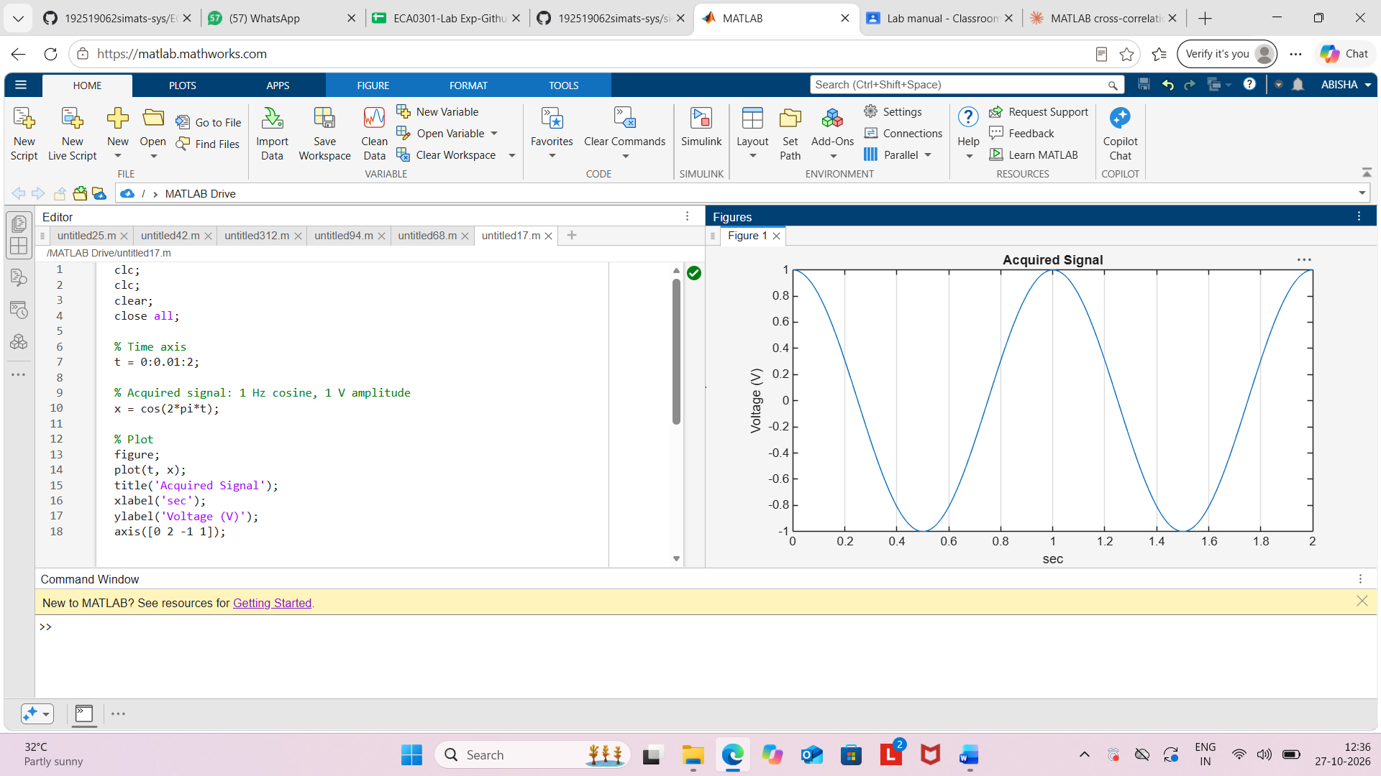
Result:
The continuous-time system y(t)=x(t)+0.5x(t−1) was analyzed using MATLAB. The output
signal was obtained by adding the present input signal and half of its delayed version. The
system response was successfully observed through the plotted waveforms.

